GDB Demonstration Document

*Note : filename should be replaced by your file name.*

/***********************************************************************

This Code uses two functions to find the sum and product.

Sum finds the sum of two numbers.

Product finds the product of two numbers.

***********************************************************************/

#include<stdio.h> int sum(int, int);

int product(int, int);

int main() {

int x,y; x=5;

y=20;

printf("The Sum is %d\n",sum(x,y));

printf("The Product is %d\n",product(x,y));

}

/***********************************************************************

Function Sum finds the sum of two integers

***********************************************************************/

int sum(int a , int b)

{

int s; s=a+b; return(s);

}

/***********************************************************************

Function Product finds the product of two integers.

***********************************************************************/

int product(int a, int b)

{

int p; p=a*b; return(p);

}

**Step 1**: Write down the above code using vi editor.

**Step 2**: Save and Quit.

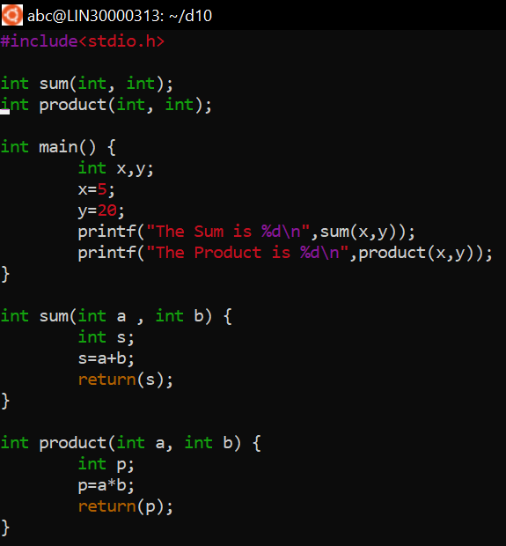

**Step 3**: Compile the code using gcc with the option –g

*gcc -g filename.c*

( The –g option with gcc, collects the symbol table information which shall be used by gdb)

**Step 4**: Execute the executable with gdb

*gdb a.out*

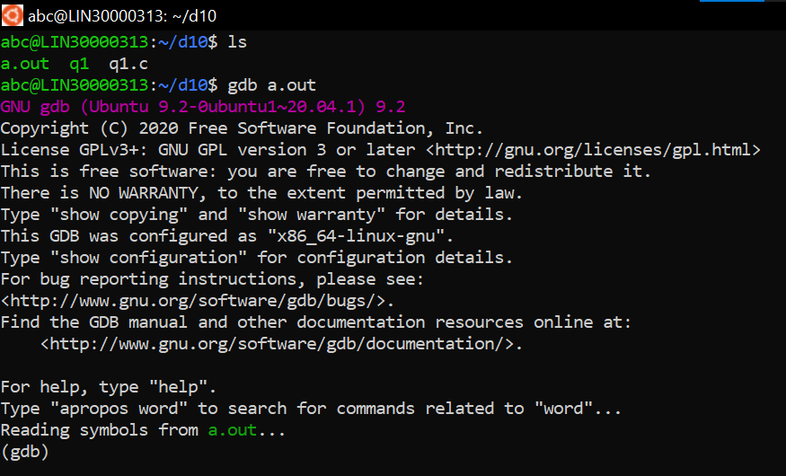

**Step 5**: List the code

(gdb) *list*

What do you observe ?

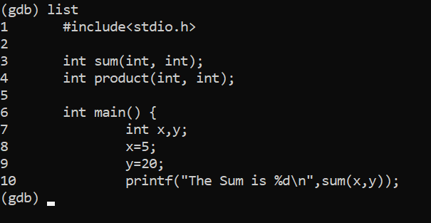

**Step 6**: If you want to list more than 10 lines, set the list size.

(gdb) *set listsize 25*

(gdb) *list*

What do you observe? ( Type *list 1* : Observe the output)

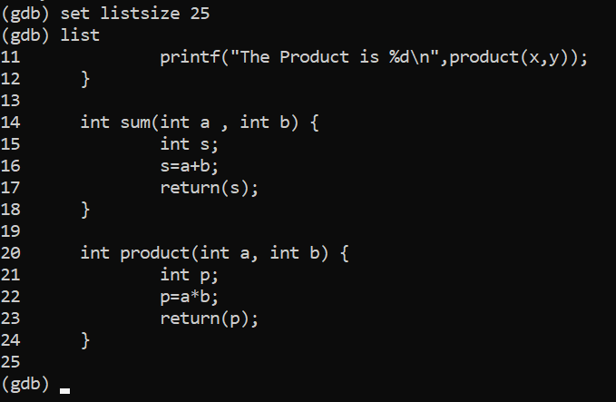

**Step 7**: Run the code.

(gdb) *r*

What do you observe ?

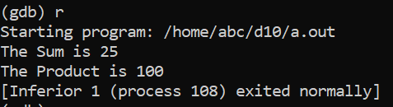

Gdb says that the “ *program exited with code 023*”

What does this mean ?

**Step 8**: Quit gdb

(gdb) *q*

**Step 9**: Edit the code. In the main function, type *‘exit(0)*’ before the last *‘}’.*

**Step 10**: Save and exit. Compile the code again with –g option. Invoke the output with gdb.

**Step 11**: Again run the program .

Now what do you observe ?

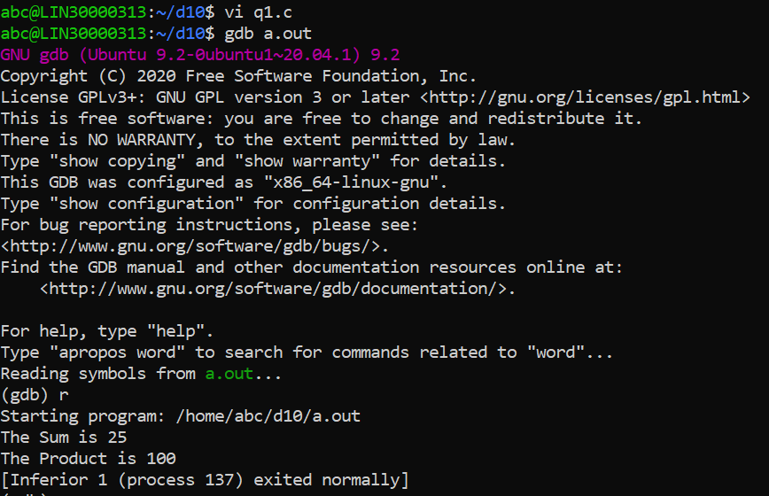

**Step 12**: Redirect the output to a file.

(gdb) *r > outputfile*

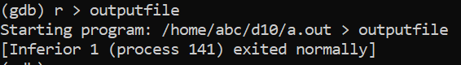

**Step 13**: quit gdb. List the contents of outputfile *cat outputfile*

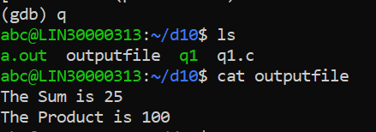

**Step 14**: Again invoke the output with gdb. List 40 lines of the code.

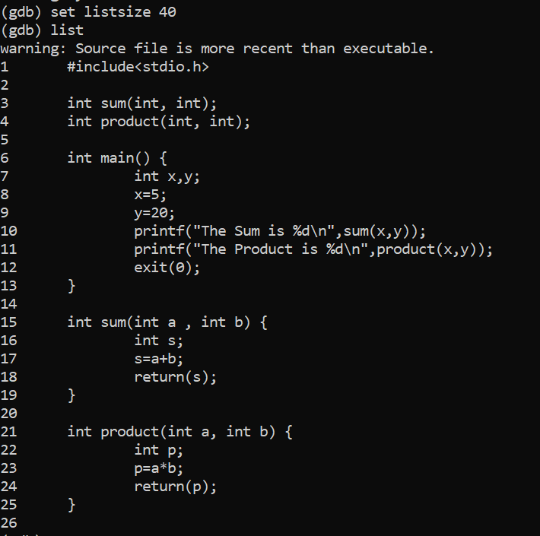

**Step 15**: Set breakpoint. At main, function sum and function product.

(gdb) *b main*  (gdb) *b 23*

(gdb) *b product.*

What do you observe ?

Breakpoints can be assigned using function name as well as line numbers.

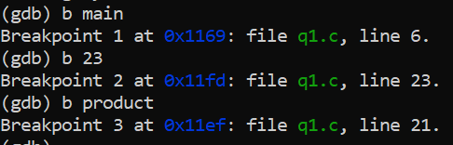

**Step 16**: List information about breakpoint.

(gdb) *info b*

What do you observe ?

The first column displays the id of each breakpoint.

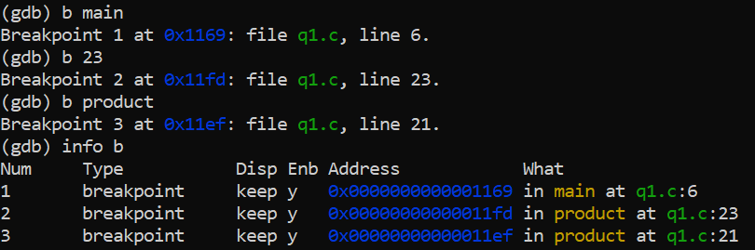

**Step 17**: Delete breakpoint with id = 1

(gdb) *d 1*



**Step 18**: Again list information on break points .

What do you observe ?

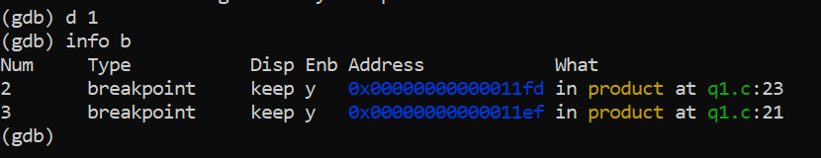

**Step 19**: Again put a break point on main.

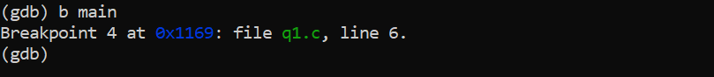

**Step 20** : Run the program

What do you observe ?

Gdb encounters the first breakpoint and waits for you.

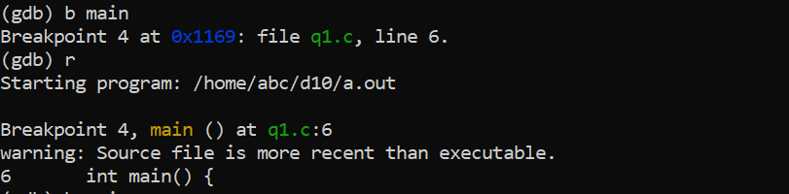

**Step 21**: To execute this line and go to next line, type the command n (next) and press enter.

(gdb*) n*



**Step 22**: Again, type n

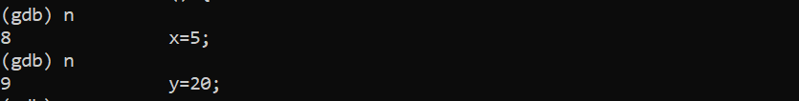

**Step 23**: Fnd out the value of a variable.

(gdb) *p x*



**Step 23** : Find the address of the variable.

(gdb*) p &x*



**Step 24**: Similarly find the value of variable y and address of y

What do you observe ? Can you explain the output ? Can you explain the address of variable x and variable y.

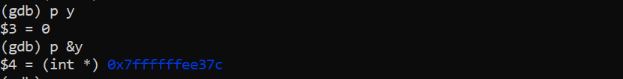

**Step 25**: Again execute the next line.

What do you observe ?

Gdb has encountered the second breakpoint.

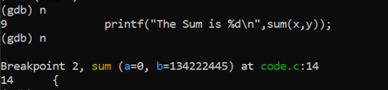

**Step 26:** You may enter the function and execute each line of function one by one.

(gdb) *s*

( Note the difference between n (next) and s (step). To go inside a function we use the command s.)

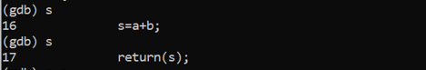

**Step 27**: Find out the value and address of variable a and variable b. What do you observe?

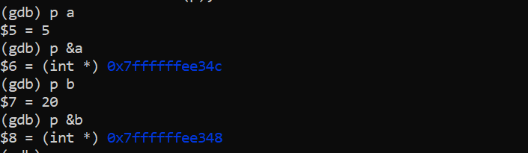

**Step 30**: Execute the next line by typing ‘n’. Find out the value and address of variable s.

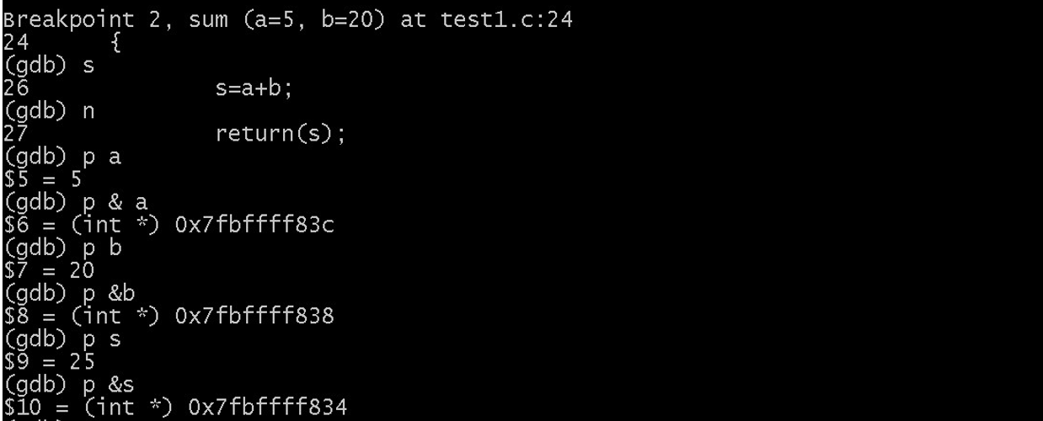

**Step 31**: List out the number of active stack frames.

(gdb) *bt*

What do you observe ?



**Step 32** : Get info about current frame.

(gdb) *info f*

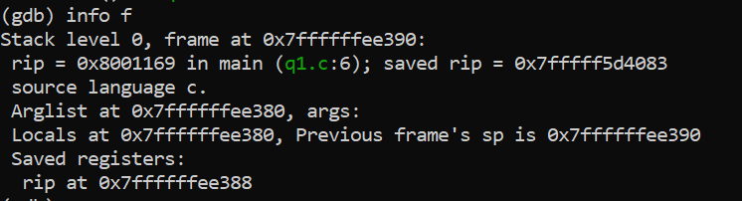

**Step 33**: Move to previous frame i.e frame number 1

(gdb*) f 1*

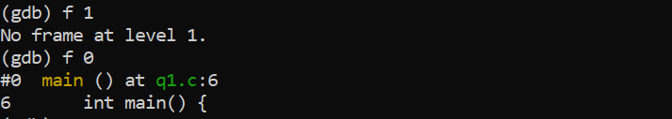

**Step 34**: List info about the current stack frame. What do you observe ?

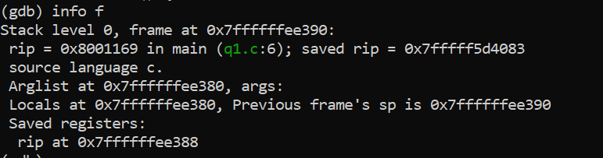

**Step 35**: Continue executing the code until you reach the next breakpoint .

(gdb) *c*

(Command c stands for continue.)

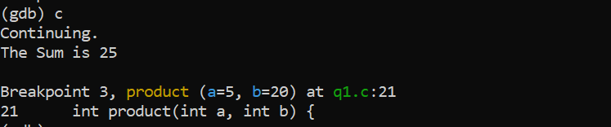

**Step 36**: Again use the command c and press enter

What do you observe?

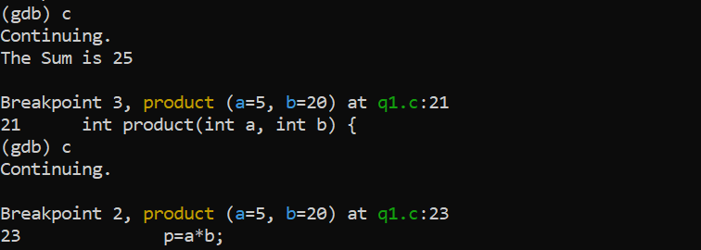

***TYPE THE FOLLOWING CODE USING VI EDITOR***.

/*****************************************************************

This program finds the sum of n natural numbers , where n is passed as a command line argument..

*****************************************************************/

#include<stdio.h>

#include<stdlib.h>

int main(int argc, char* argv[])

{

int input ,sum, count;

if (argc < 2)

{

printf("Enter the number as a command line arg\n"); exit(1);

}

//We need to convert the argument string to number

//Call Library Function atoi, which converts the string to number

input = atoi(argv[1]); sum = 0;

for(count=1 ; count <=input ; count++)

{

sum = sum + count;

}

printf("The sum is %d\n",sum);

return 0;

}

**Step 1**: Compile the code using gcc with option –g and invoke gdb (**gdb a.out**)

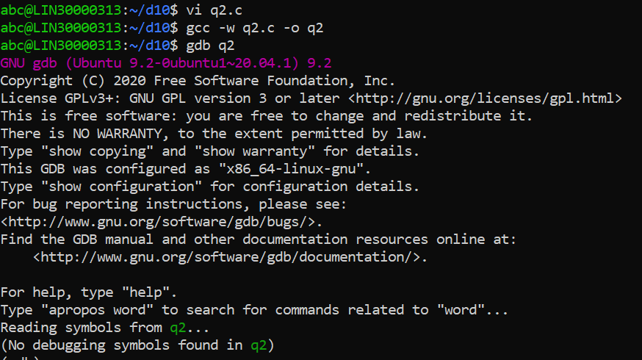

**Step 2**: Assign a breakpoint at main. (**b main**)



**Step 3**: Breakpoints can be disabled and enabled using the following commands:

(gdb) *dis <id>*

(gdb*) en <id>*

Check the status of the breakpoint after disabling and enabling the breakpoint

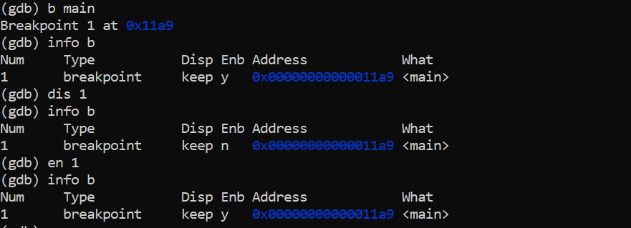

**Step 4**: A watchpoint is a special breakpoint that stops your program when the

Value of an expression changes. Let us put a watchpoint on variable sum in main.

(gdb) *b main*

(gdb*) r 5 ( Here execute the code with command Line Argument -5)*

(gdb) *n*

(gdb) *watch sum*

(gdb) *c*

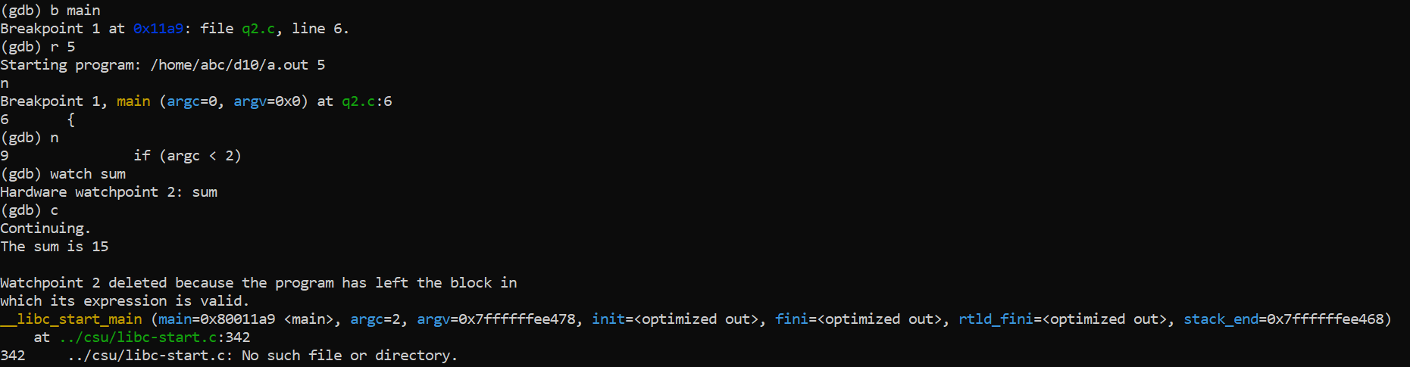

,

What do you observe ? (**After you continue the program stops when the value of the variable sum changes ..Press Enter to continue or n (next to execute next line of code)**

*Note: When you run the program using command r , you can provide the command line argument.(Which is 5 in this example)*

***Some more gdb useful Commands***

To execute a shell command

gdb> shell <cmd to execute>

To view the contents of a memory location

# /15c <address> //display 15 characters

To set a break with condition

Consider the code below in myfile.c, where to break when i = 4

1. for (i = 0; i < 10; i++)
2. { 22 ret +=i;

....

25 }

gdb>break myfile.c:21 if (i == 4)

To view the assembly code with source

# gdb> disassem /m